Supply Chain Management Dashboard

By Biswanandan Hota

# Project Overview

This project involves building an interactive Supply Chain Management (SCM) Dashboard in Tableau using supply chain data from a Fashion and Beauty startup.   
The primary goal is to monitor and optimize key aspects of the supply chain such as inventory levels, supplier performance, shipping efficiency, and costs, using the available dataset.

# Dataset Summary

The dataset contains the following key fields:  
- Product Type, SKU, Price, Availability  
- Number of products sold, Revenue generated  
- Stock levels, Lead times, Order quantities  
- Shipping times, Shipping carriers, Shipping costs  
- Supplier name, Location, Manufacturing costs, Defect rates  
- Transportation modes, Routes, Costs

# Dashboard Components

## 1. Inventory Management

- Bar Chart: Displays current Stock levels by Product Type or SKU.  
- Helps visualize inventory distribution and identify products with low or high stock.

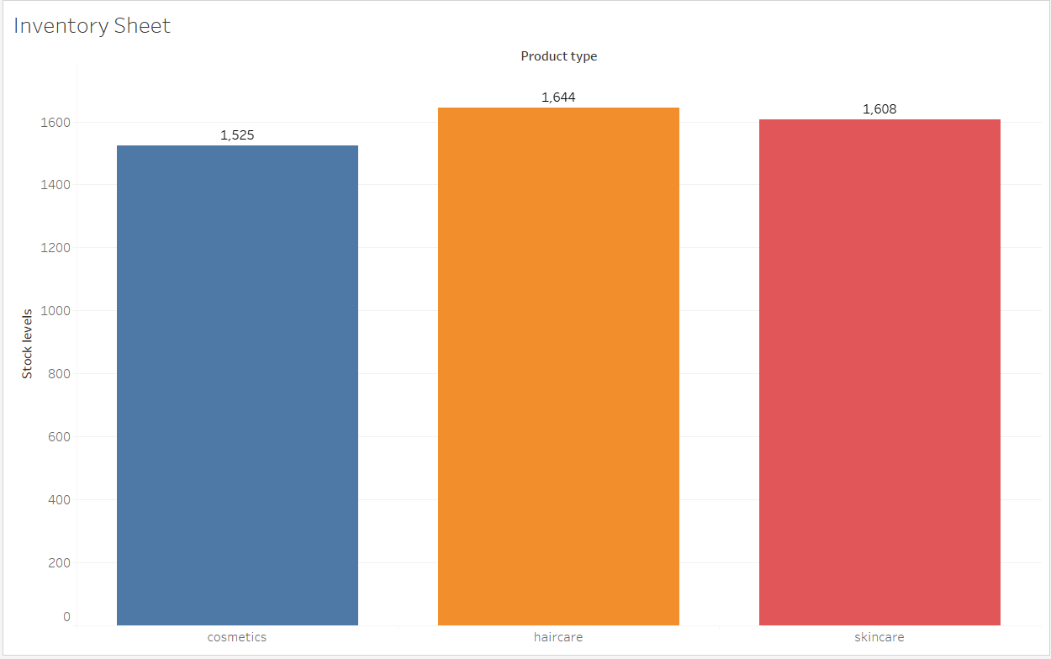

## 2. Supplier Lead Times

- Line Chart: Shows average Lead times by Supplier name.  
- Provides insight into supplier delivery speed.

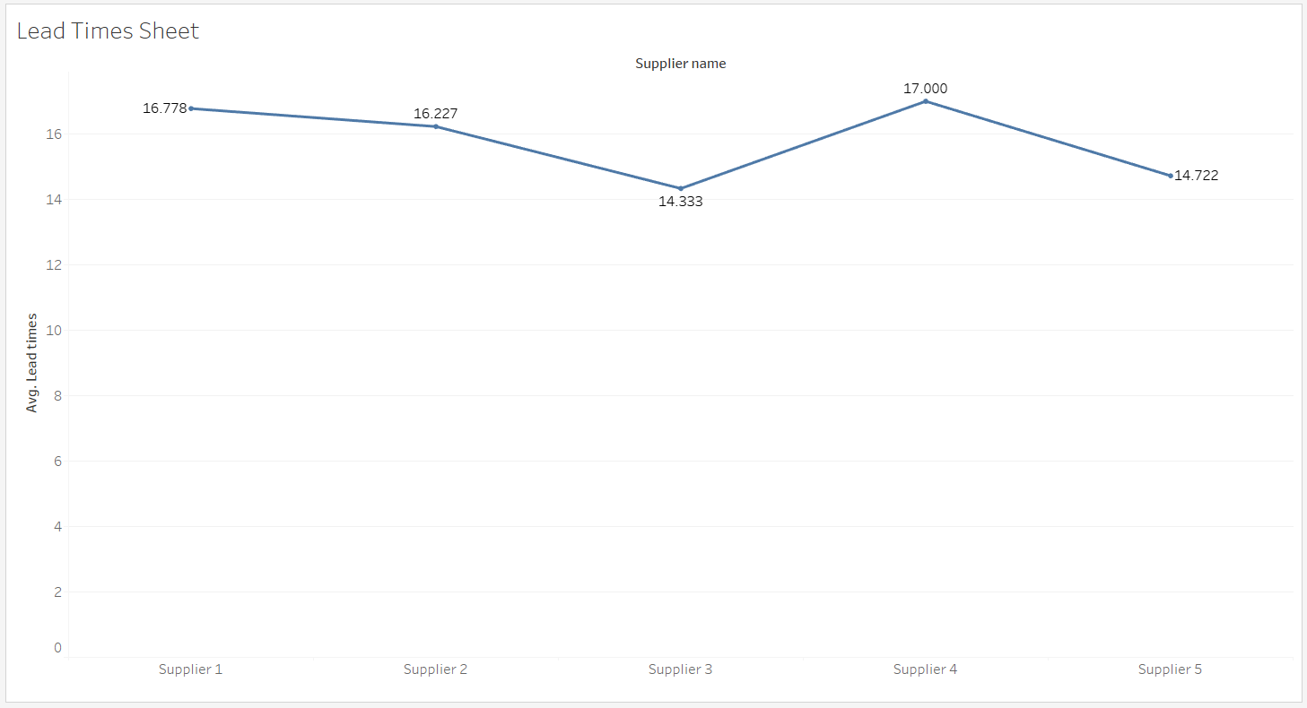

## 3. Supplier Performance

- Bar Chart: Visualizes average Defect rates by Supplier name.  
- Assesses the quality performance of each supplier.

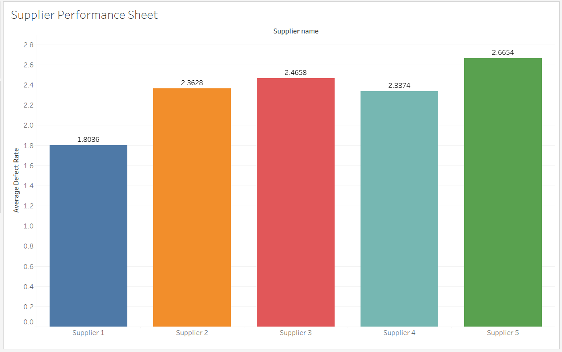

## 4. Shipping Efficiency

- Bar or Line Chart: Depicts average Shipping times by Shipping carriers or Transportation modes.  
- Evaluates the efficiency of shipping partners and transportation methods.

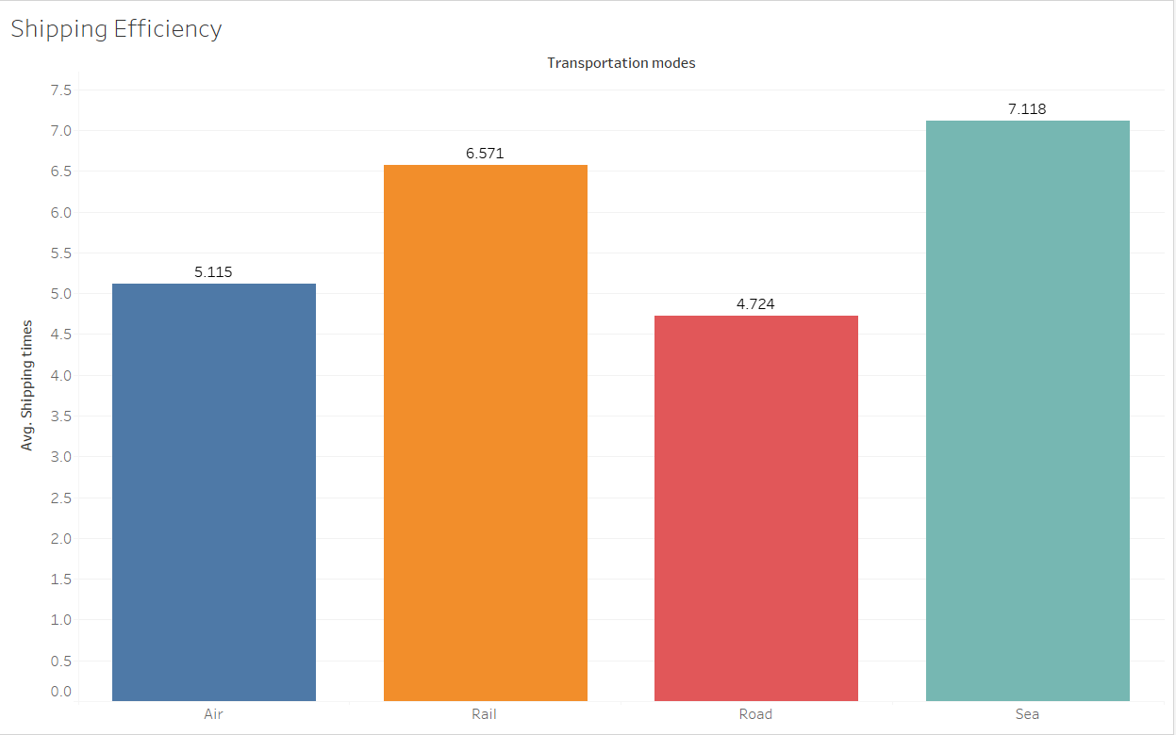

## 5. Cost Overview

- Pie Chart: Shows total Costs by Supplier name.  
- Highlights which suppliers contribute most to overall supply chain costs.

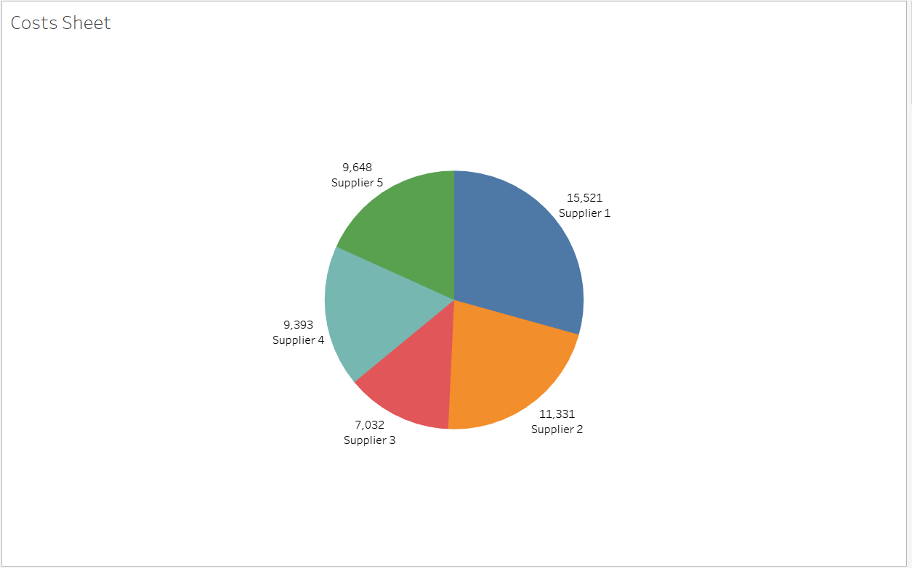

## 6. Dashboard

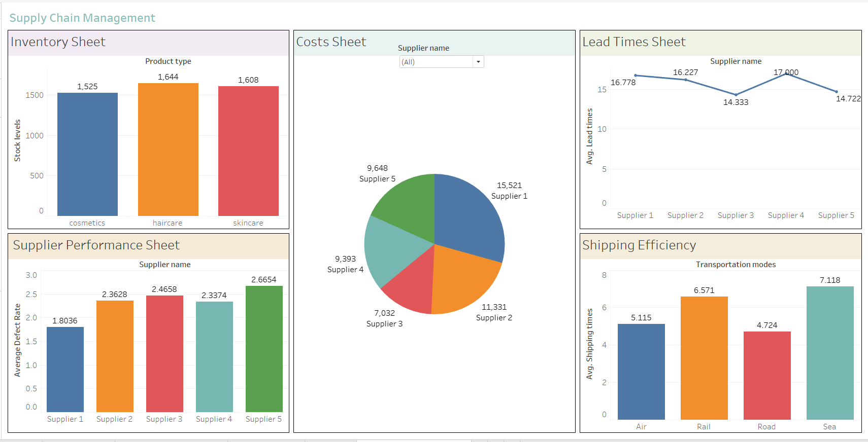

# Key Calculated Fields in Tableau

- Average Lead Time = AVG([Lead times])  
- Average Defect Rate = AVG([Defect rates])  
- Average Shipping Time = AVG([Shipping times])  
- Total Costs = SUM([Costs])  
- Total Inventory = SUM([Stock levels])

# Benefits of this Dashboard

✅ Quickly identify bottlenecks in the supply chain (e.g., high lead times or defect rates).  
✅ Compare suppliers by delivery performance and cost impact.  
✅ Monitor inventory levels to ensure optimal stock availability.  
✅ Analyse shipping partners’ efficiency to streamline logistics.  
✅ Support data-driven decision-making to enhance overall supply chain operations.